Cobh Ramblers Bus Approach
This is the route to be taken by all buses.
https://maps.app.goo.gl/mW7q2auQptG4kCdj9
Please do not turn left when coming over Belvelly Bridge
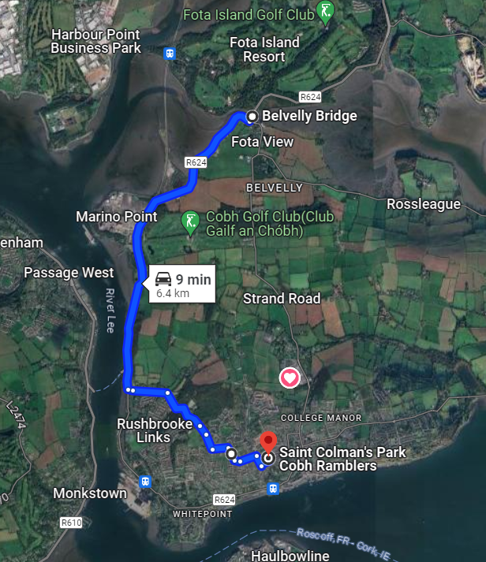

Cobh Ramblers Bus Approach
Approaching the ground is via the Green Route Indicated below.
There is a turning area at 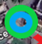 this point but we advise it is tight in this area at particular times during the day.
Leaving the ground is as per the Blue Route (green in reverse). Orange Route is possible but dependant on parking in that area.
The Red X Routes are not passible and should not be used under any circumstances.
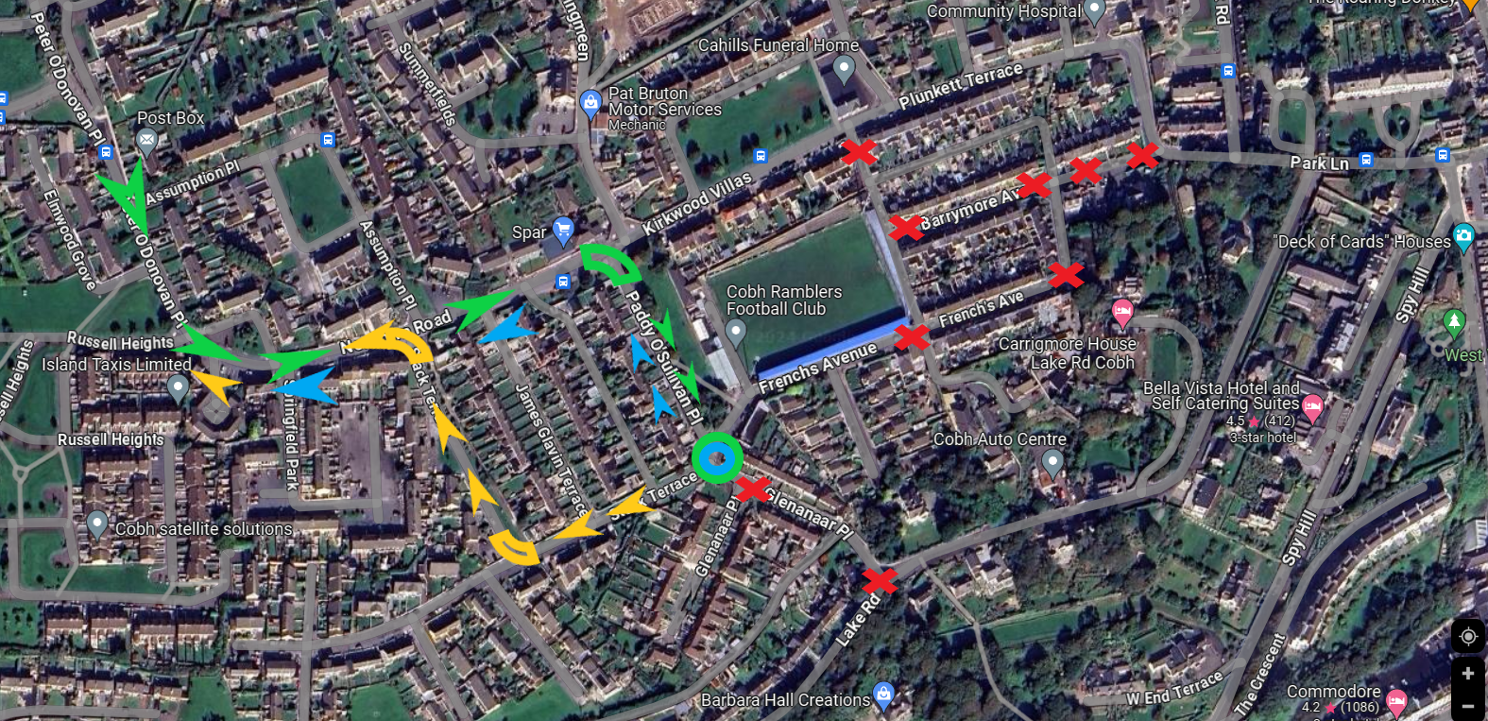
Cobh Ramblers Bus Approach
For LOI Senior Games Only: An area will be cleared directly outside the ground as per the Red Circle below.
For all other games buses should drop at the blue area and then travel away and park away from the area.
Limited parking may be available at the orange circle area, but this is traffic and neighbour permissive dependant.
Under no circumstances should a bus be parked in any other area in the vicinity of the ground.
